1. Make sure your files are structured for a simulation in the Sources pane. This means that the testbench is the top level and the target entity/architecture is nested below
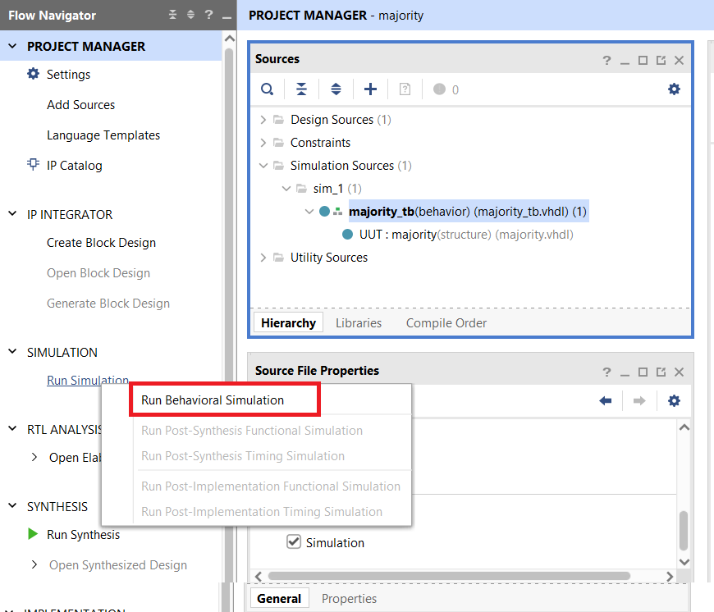
2. Click on the Run Simulation in the Project Manager area and then on Run Behavioral Simulation.
3. If everything is configured correctly, the Simulation window will appear.
- The signals in the Objects pane reflect the entity selected in the Scope area. Select the UUT entity.
- The waveform is in the Untitled 2 tab at right. Click on the Untitled 2 tab.
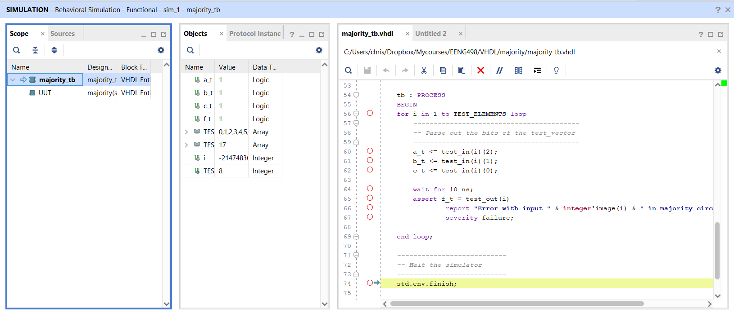

4. Once you have the timing diagram visible, you may want to try the following:
- Click on the Zoom Fit tool at the top of the simulation pane to see the entire simulation.
- Check the TCL Console pane for any errors found in your self-checking testbench.
- Delete signals in the timing diagram by selecting them and pressing delete on your keyboard.
- Add signals to the timing diagram by
  - Dragging them from the Objects pane to the timing diagram or
  - Running a TCL script. Do this by:
    - Downloading provided TCL script into the project’s root directory
    - In the Tcl command area change directory to the project’s root directory.
cd C:/Users/Chris/Dropbox/Mycourses/EENG498/Lab01
    - In the Tcl command area run the TCL script
source pwm_tbWaveSetup.tcl
- Restart your simulation by clicking Run -> Restart or by typing “restart” in the TCL command area.
- Run your simulation typing run 100ns in the TCL command area
- You can double click the timing diagram tab to maximize the size of the timing diagram. You can also undock the timing diagram and make it the width of the screen.

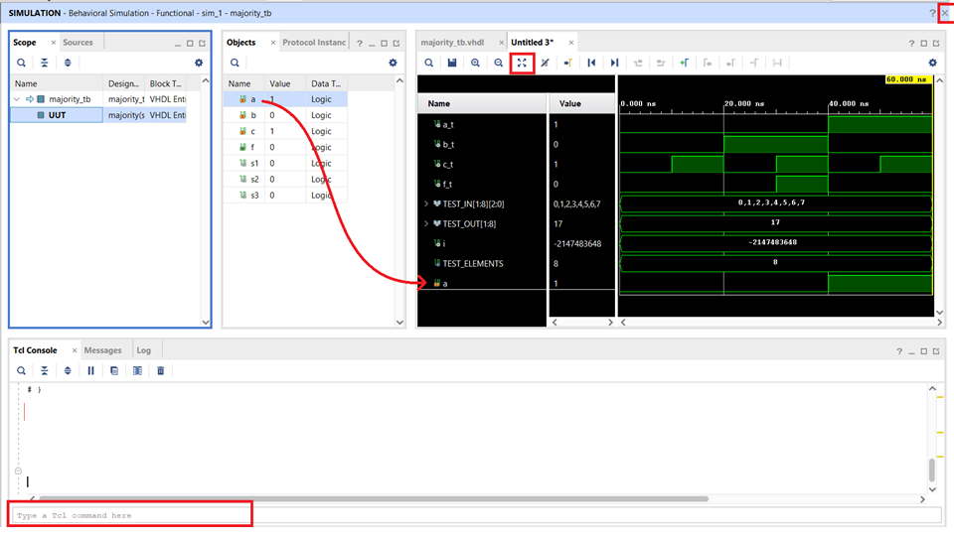

5. Close the simulation by clicking on the “x” in the upper right corner of the SIMULATION window. Discard any changes.

6. Fix any logic errors, relaunch the simulator, delete the testbench signals from the waveform and add the UUT signals, color the signals and turn-in.
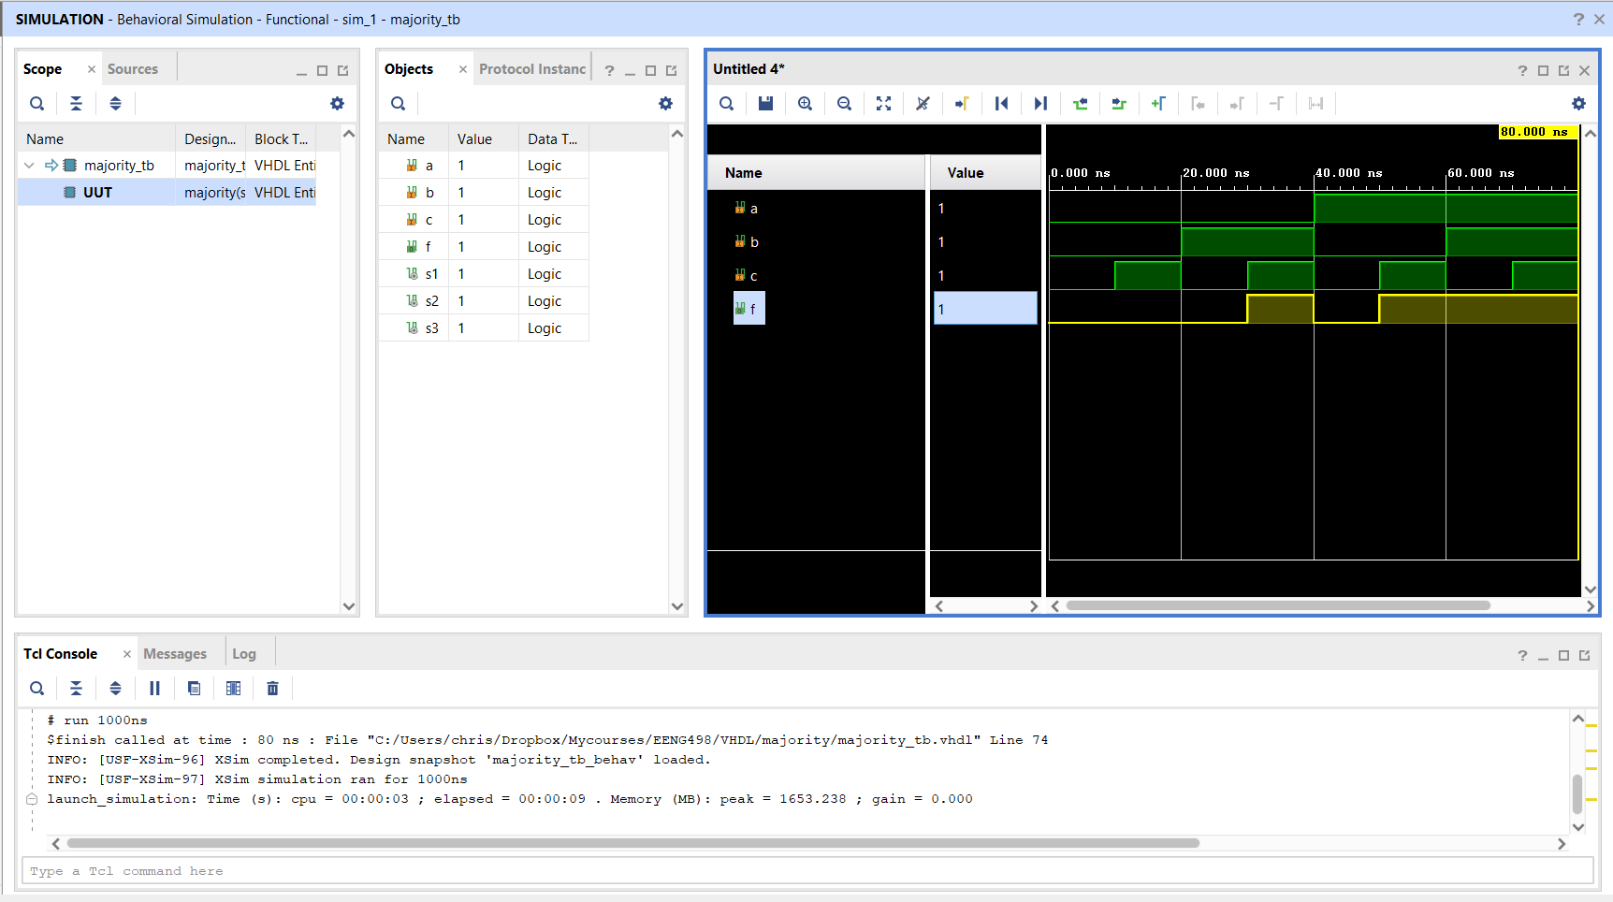

7. You are now ready to synthesize your design and download it to the ALINX board.

Note: If you are making changes to your source code and then not seeing the simulation output reflect these changes, you may want to turn off incremental compilation. You can do this by clicking on the settings option in the Project Manager side bar. In the Setting pop-up, click on the Simulation option in the Project Setting side bar, click the Advanced tab and then uncheck “Enable Incremental Compilation”
